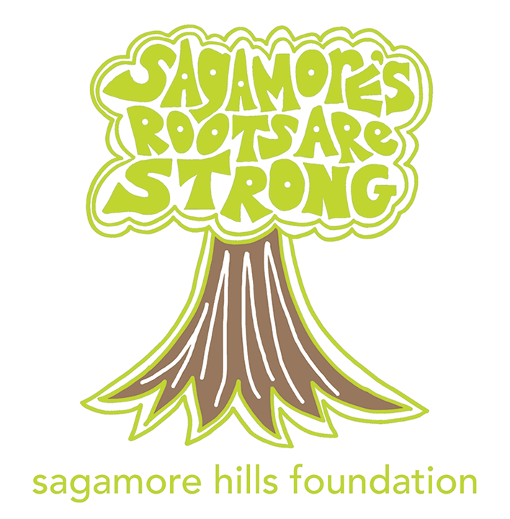Sagamore Hills Elementary Foundation Sponsorship Form
We value our Sponsorship Partners and promise to use your gift to improve the educational experience of every student at Sagamore Hills Elementary to the best of our ability. All donations are tax deductible.

Visit sagamorehillsfoundation.org to see the giving level benefits

[ ] | Meow! | $5,000 +
[ ] | Purrr… | $2,500 – $4,999
[ ] | Catnip | $1,000 – $2,499
[ ] | Cool Cat | $500 – $999
[ ] | Tiger Stripe | $250 – $499
[ ] |  | ___________

SPONSOR CONTACT INFORMATION
PERSON/ORGANIZATION (AS IT SHOULD APPEAR IN PRINTED MATERIAL)
_____________________________________________________________________________________
CONTACT NAME CONTACT TITLE
_____________________________________________________________________________________
MAILING ADDRESS
_____________________________________________________________________________________
CITY STATE ZIP
_____________________________________________________________________________________
TELEPHONE EMAIL
_____________________________________________________________________________________
WEBSITE

METHOD OF PAYMENT/DONATION
[ ] Gift card or other tangible/in-kind donation: VALUED AMOUNT: $_____________________
[ ] CHECK ENCLOSED (made payable to Sagamore Hills Foundation)
[ ] PLEASE SEND AN INVOICE
[ ] PLEASE CHARGE MY CREDIT CARD:

[ ] MASTERCARD [ ] VISA [ ] DISCOVER [ ] AMEX

CC #: _______________________________________________________________________

EXP: _______________ SIGNATURE:____________________________________________
This signature authorizes the Sagamore Hills Foundation to charge the credit card number the stated and agreed upon amount. The credit card information will be securely destroyed immediately after processing.

Please email any questions to info@sagamorehillsfoudation.org
The Foundation is a non-profit 501 (c) (3) organization formed by parents and teachers that supports the quality of education at Sagamore Hills Elementary School in Dekalb County, Georgia.

